* **Lab Task 2**

Write a SQL statement that uses a subquery to display the plane ID, model, and capacity of planes that have a higher capacity than the average capacity.

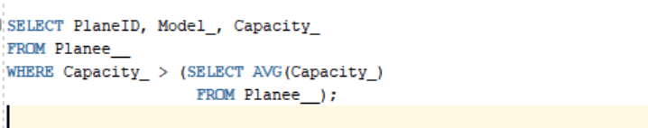

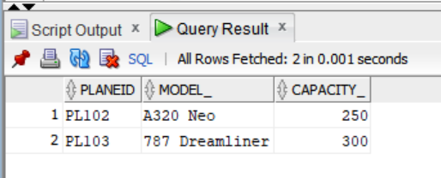

OUTPUT: